# Libraries

import numpy as np import pandas as pd

import matplotlib.pyplot as tlp

%matplotlib inline import seaborn as ss

# Loading the dataset

from google.colab import files upload=files.upload()

a=pd.read_csv('/content/abalone.csv') a.head()

Sex Length Diameter Height Whole weight Shucked weight Viscera weight \

0 M 0.455 0.365 0.095 0.5140 0.2245

0.1010

1 M 0.350 0.265 0.090 0.2255 0.0995

0.0485

2 F 0.530 0.420 0.135 0.6770 0.2565

0.1415

3 M 0.440 0.365 0.125 0.5160 0.2155

0.1140

4 I 0.330 0.255 0.080 0.2050 0.0895

0.0395

Shell weight Rings 0 0.150 15

1 0.070 7

2 0.210 9

3 0.155 10

4 0.055 7

a['age']=a['Rings']+1.5 a=a.drop('Rings',axis=1)

# A. univariate Analysis

ss.kdeplot(a['Diameter'])

<matplotlib.axes._subplots.AxesSubplot at 0x7fbad1961d90>

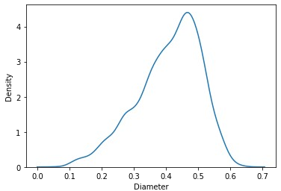

# Bi-Variate Analysis

ss.boxplot(x=a.Diameter,y = a.Length, palette='rainbow')

<matplotlib.axes._subplots.AxesSubplot at 0x7fbad1844c50>

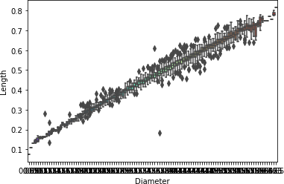

# Multi-Variate Analysis

ss.pairplot(a)

<seaborn.axisgrid.PairGrid at 0x7fbad096df50>

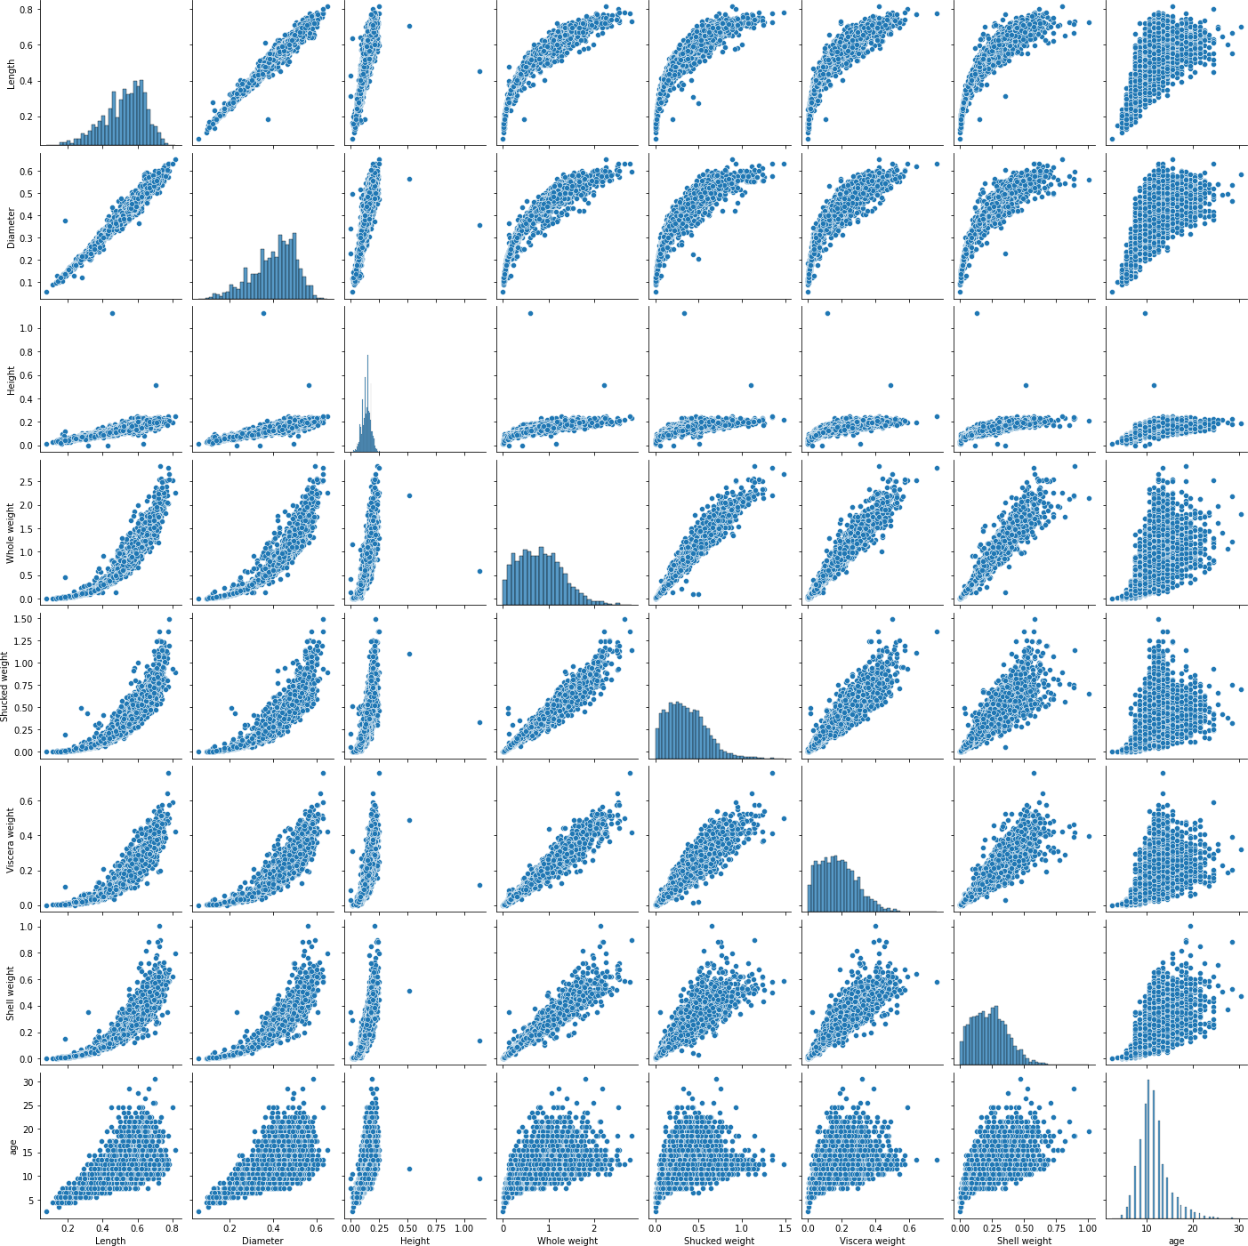

# Descriptive Statistics

a.info()

<class 'pandas.core.frame.DataFrame'> RangeIndex: 4177 entries, 0 to 4176 Data columns (total 9 columns):

# Column Non-Null Count Dtype

1. Sex 4177 non-null object
2. Length 4177 non-null float64
3. Diameter 4177 non-null float64
4. Height 4177 non-null float64
5. Whole weight 4177 non-null float64
6. Shucked weight 4177 non-null float64
7. Viscera weight 4177 non-null float64
8. Shell weight 4177 non-null float64
9. age 4177 non-null float64 dtypes: float64(8), object(1)

memory usage: 293.8+ KB a['Diameter'].describe()

count 4177.000000

mean 0.407881

std 0.099240

min 0.055000

25% 0.350000

50% 0.425000

75% 0.480000

max 0.650000

Name: Diameter, dtype: float64 a['Sex'].value_counts

<bound method IndexOpsMixin.value_counts of 0 M

1. M
2. F
3. M

4 I

..

4172 F

4173 M

4174 M

4175 F

4176 M

Name: Sex, Length: 4177, dtype: object> 5.Checking for missing values and dealing with them a.isnull()

Sex Length Diameter Height Whole weight Shucked weight \

1. False False False False False False
2. False False False False False False
3. False False False False False False
4. False False False False False False
5. False False False False False False

... ... ... ... ... ... ...

4172 False False False False False False 4173 False False False False False False 4174 False False False False False False 4175 False False False False False False 4176 False False False False False False

Viscera weight Shell weight age

1. False False False
2. False False False
3. False False False
4. False False False
5. False False False

... ... ... ...

4172 False False False

4173 False False False

4174 False False False

4175 False False False

4176 False False False

[4177 rows x 9 columns] a.isnull().sum()

Length 0

Diameter 0

Height 0

Whole weight 0

Shucked weight 0

Viscera weight 0

Shell weight 0

age 0

Sex_F 0

Sex_I 0

Sex_M 0

dtype: int64

# Find the outliers and replace the outliers

a=pd.get_dummies(a) dummy_a=a var='Viscera weight'

tlp.scatter(x=a[var],y=a['age'])

tlp.grid(True)

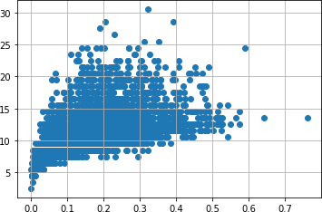

a.drop(a[(a['Viscera weight']>0.5)& (a['age']<20)].index, inplace=True)

a.drop(a[(a['Viscera weight']<0.5)&(a['age']>25)].index, inplace=True)

var='Shell weight' tlp.scatter(x=a[var],y=a['age']) tlp.grid(True)

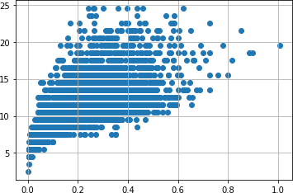

a.drop(a[(a['Shell weight'] > 0.6) &

(a['age'] < 25)].index, inplace = True)

a.drop(a[(a['Shell weight']<0.8) & ( a['age'] > 25)].index, inplace = True)

var = 'Shucked weight'

tlp.scatter(x = a[var], y =a['age']) tlp.grid(True)

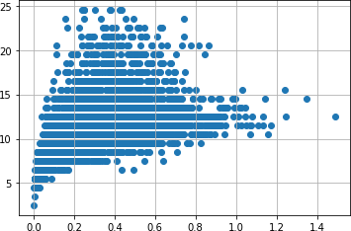

a.drop(a[(a['Whole weight'] >= 2.5) &

(a['age'] < 25)].index, inplace = True) a.drop(a[(a['Whole weight']<2.5) & (

a['age'] > 25)].index, inplace = True)

var = 'Diameter'

tlp.scatter(x = a[var], y = a['age']) tlp.grid(True)

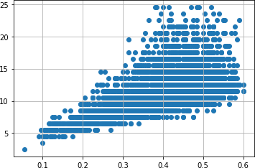

a.drop(a[(a['Diameter'] <0.1) &

(a['age'] < 5)].index, inplace = True)

a.drop(a[(a['Diameter']<0.6) & ( a['age'] > 25)].index, inplace = True) a.drop(a[(a['Diameter']>=0.6) & ( a['age'] < 25)].index, inplace = True)

var = 'Height'

tlp.scatter(x = a[var], y = a['age']) tlp.grid(True)

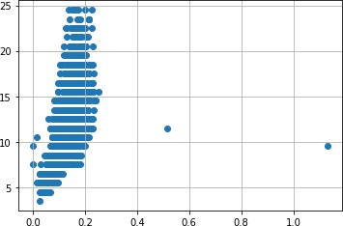

a.drop(a[(a['Height'] > 0.4) &

(a['age'] < 15)].index, inplace = True) a.drop(a[(a['Height']<0.4) & (

a['age'] > 25)].index, inplace = True)

var = 'Length'

tlp.scatter(x = a[var], y = a['age']) tlp.grid(True)

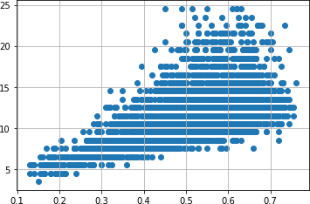

a.drop(a[(a['Length'] <0.1) &

(a['age'] < 5)].index, inplace = True)

a.drop(a[(a['Length']<0.8) & ( a['age'] > 25)].index, inplace = True)

a.drop(a[(a['Length']>=0.8) & (a['age'] < 25)].index, inplace = True)

# Checking for categorical columns

numerical_features = a.select_dtypes(include = [np.number]).columns categorical_features = a.select_dtypes(include = [np.object]).columns

/usr/local/lib/python3.7/dist-packages/ipykernel_launcher.py:2: DeprecationWarning: `np.object` is a deprecated alias for the builtin

`object`. To silence this warning, use `object` by itself. Doing this will not modify any behavior and is safe.

Deprecated in NumPy 1.20; for more details and guidance: https://numpy.org/devdocs/release/1.20.0-notes.html#deprecations

numerical_features

Index(['Length', 'Diameter', 'Height', 'Whole weight', 'Shucked weight',

'Viscera weight', 'Shell weight', 'age', 'Sex_F', 'Sex_I', 'Sex_M'],

dtype='object') categorical_features Index([], dtype='object')

# Encoding

from sklearn.preprocessing import LabelEncoder le=LabelEncoder() print(a.Length.value_counts())

0.550 93

0.575 93

0.625 93

0.580 92

0.600 86

..

0.755 2

0.220 2

0.150 1

0.135 1

0.760 1

Name: Length, Length: 126, dtype: int64

x=a.iloc[:,:5] x

Length Diameter Height Whole weight Shucked weight 0 0.455 0.365 0.095 0.5140 0.2245

1 0.350 0.265 0.090 0.2255 0.0995

2 0.530 0.420 0.135 0.6770 0.2565

3 0.440 0.365 0.125 0.5160 0.2155

4 0.330 0.255 0.080 0.2050 0.0895

... ... ... ... ... ... 4172 0.565 0.450 0.165 0.8870 0.3700

4173 0.590 0.440 0.135 0.9660 0.4390

4174 0.600 0.475 0.205 1.1760 0.5255

4175 0.625 0.485 0.150 1.0945 0.5310

4176 0.710 0.555 0.195 1.9485 0.9455

[4096 rows x 5 columns] y=a.iloc[:,:5]

y

Length Diameter Height Whole weight Shucked weight 0 0.455 0.365 0.095 0.5140 0.2245

1 0.350 0.265 0.090 0.2255 0.0995

2 0.530 0.420 0.135 0.6770 0.2565

3 0.440 0.365 0.125 0.5160 0.2155

4 0.330 0.255 0.080 0.2050 0.0895

... ... ... ... ... ... 4172 0.565 0.450 0.165 0.8870 0.3700

4173 0.590 0.440 0.135 0.9660 0.4390

4174 0.600 0.475 0.205 1.1760 0.5255

4175 0.625 0.485 0.150 1.0945 0.5310

4176 0.710 0.555 0.195 1.9485 0.9455

[4096 rows x 5 columns]

# Spliting the data into training and testing

from sklearn.model_selection import train_test_split x_train,x_test,y_train,y_test=train_test_split(x,y,test_size=0.2)

# Building the model

from sklearn.linear_model import LinearRegression mlr=LinearRegression()

mlr.fit(x_train,y_train) LinearRegression() 11.Training the model 12.Testingthe model

x_test[0:5]

Length Diameter Height Whole weight Shucked weight 2358 0.610 0.485 0.210 1.3445 0.5350

723 0.525 0.410 0.130 0.9900 0.3865

2535 0.640 0.500 0.180 1.4995 0.5930

2717 0.345 0.255 0.095 0.1830 0.0750

29 0.575 0.425 0.140 0.8635 0.3930

y_test[0:5]

Length Diameter Height Whole weight Shucked weight 2358 0.610 0.485 0.210 1.3445 0.5350

723 0.525 0.410 0.130 0.9900 0.3865

2535 0.640 0.500 0.180 1.4995 0.5930

2717 0.345 0.255 0.095 0.1830 0.0750

29 0.575 0.425 0.140 0.8635 0.3930

# Scaling the independent variables

from sklearn.preprocessing import StandardScaler ss=StandardScaler() x_train=ss.fit_transform(x_train)

mlrpred=mlr.predict(x_test[0:9])

mlrpred

array([[0.61 , 0.485 , 0.21 , 1.3445, 0.535 ],

[0.525 , 0.41 , 0.13 , 0.99 , 0.3865],

[0.64 , 0.5 , 0.18 , 1.4995, 0.593 ],

[0.345 , 0.255 , 0.095 , 0.183 , 0.075 ],

[0.575 , 0.425 , 0.14 , 0.8635, 0.393 ],

[0.57 , 0.48 , 0.18 , 0.9395, 0.399 ],

[0.61 , 0.485 , 0.165 , 1.087 , 0.4255],

[0.635 , 0.505 , 0.17 , 1.2635, 0.512 ],

[0.53 , 0.41 , 0.155 , 0.7155, 0.2805]])

# Measuring the performance using metrics

from sklearn.metrics import r2_score r2_score(mlr.predict(x_test),y_test)

1.0